BEGINNERS CHORDS – MAKING THE “D” CHORD
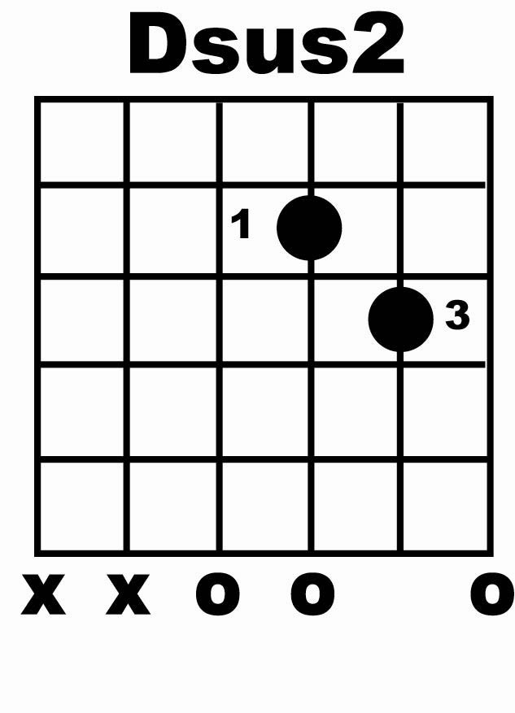
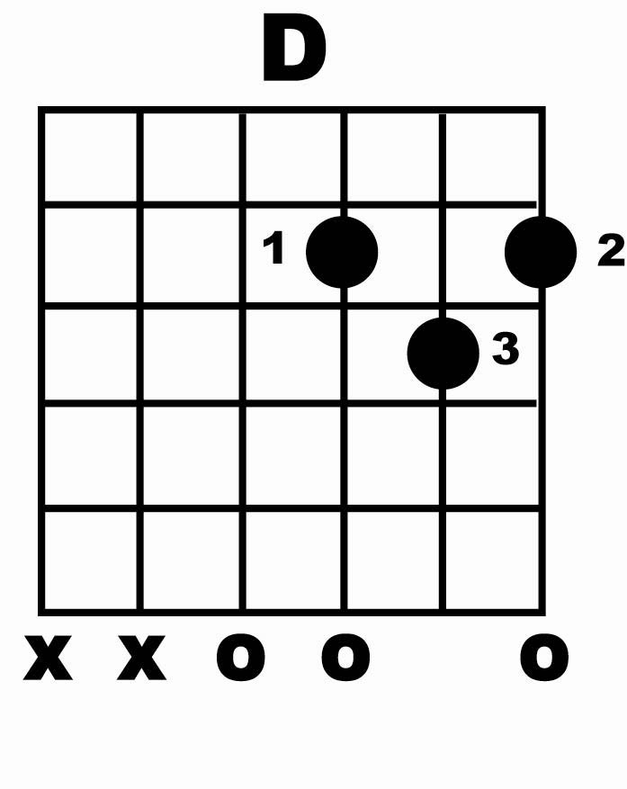

DO play the O’s
DON’T play the “X’s”.

6= downstroke 5= upstroke

All D Chords are played using top 4 strings only.

Dsus2 D
       

Dsus2 D
       

Try adding in the “up” strokes:

Dsus2 D
 

Dsus2 D
 

NOTE:

Make sure all chords sound “clean” i.e, no buzzing from strings etc…if you hear a “buzzing” sound just practice picking through each string one a time until this goes away.

Keep all the rhythms smooth and even don’t rush the rhythm. Playing rhythm in songs requires a consistent flowing style – so take your time with it.

